SOFTWARE REQUIREMENT SPECIFICATION (SRS)
Senior Citizen Companionship and Task-Assistance App
Scenario-Based Requirement Analysis — CO2 Assessment Tool 1
SIMATS Engineering (Saveetha School of Engineering)
Department of Computer Science and Engineering
Course Code: CSA10 / CSA1063 | Course Title: Software Engineering
CO2 Statement: Perform detailed requirements analysis, design scalable architectures, and prioritize features with a focus on cross-disciplinary skills
Student Name: ____________________________
Reg. No.: ____________________________
Date: ____________________________

1. Introduction

1.1 Purpose
This document presents the Software Requirement Specification (SRS) for the Senior Citizen Companionship and Task-Assistance App. The purpose of this application is to support elderly individuals living independently by providing daily task assistance, AI-driven companionship, health monitoring, and emergency support, while giving caregivers and family members visibility and peace of mind. This SRS defines the functional and non-functional requirements, system actors, use cases, data requirements, interfaces, assumptions, and constraints that will guide the design and development of the system.

1.2 Intended Audience
- Software development team (designers, developers, testers)
- Project stakeholders and academic evaluators
- Healthcare and assisted-living service providers
- Caregivers, family members, and elderly end users

1.3 Business Domain and Objectives
The application belongs to the Healthcare and Assisted Living Technology domain, specifically the growing sector of AgeTech (Aging-in-Place technology). The key objectives are:
- Develop a user-friendly mobile application for senior citizens.
- Provide AI-based companionship through conversational assistance.
- Manage daily schedules, reminders, and medication alerts.
- Enable emergency notifications and caregiver communication.
- Support health and wellness monitoring.
- Facilitate voice and video communication with family members.
- Ensure secure and privacy-preserving data management.
- Promote independent and safe living for elderly individuals.

2. Problem Description
Many elderly individuals live independently and face challenges such as loneliness, forgetfulness of medication and appointments, difficulty managing daily tasks, and delayed emergency response. Caregivers and family members, who are frequently unable to be physically present, need a reliable way to remotely monitor the well-being of their elderly relatives. Existing solutions are often fragmented — reminder apps, health trackers, and communication tools exist separately, forcing elderly users (who may have limited digital literacy) to navigate multiple applications. There is a need for a single, accessible, AI-powered platform that combines companionship, task assistance, health monitoring, and emergency response in one intuitive interface.

2.1 Stakeholders
Stakeholder | Role / Interest
Senior Citizen (Primary User) | Uses the app daily for reminders, companionship, health tracking, and emergency assistance.
Caregiver / Family Member | Monitors the senior's well-being remotely, receives alerts, and communicates via the app.
Healthcare Provider | Optionally receives shared health data and emergency notifications.
Emergency Services | Receives automated emergency alerts with the senior's location.
System Administrator | Manages user accounts, system configuration, and platform security.
App Development/Operations Team | Builds, maintains, and supports the application and backend infrastructure.

3. Scope of the System
The system is a cross-platform mobile application (with an optional companion web portal for caregivers) that provides:
- Medication and appointment reminders with adherence tracking.
- An AI-powered conversational assistant for companionship, reminders, and simple queries.
- Daily task management (to-do lists, routines).
- One-tap emergency alerts with automatic location sharing to caregivers and, where configured, emergency services.
- Health and wellness monitoring, including optional integration with wearable devices.
- Secure voice and video calling between the senior and family/caregivers.
- Caregiver dashboard for remote monitoring, notifications, and reminder management.
Out of scope for the initial release: in-app medical diagnosis, prescription dispensing/ordering, robotic/physical assistance devices, and direct integration with hospital Electronic Health Record (EHR) systems (planned for a future phase).

4. Functional Requirements
The following functional requirements (FR) define the required behavior of the system, grouped by module.

4.1 User & Profile Management
- The system shall allow a senior citizen to register and create a profile with basic personal, health, and emergency-contact information.
- The system shall allow linking of one or more caregiver/family accounts to a senior citizen's profile, with the senior's consent.
- The system shall provide simplified, accessible registration and login (e.g., large text, voice-guided setup, optional caregiver-assisted setup).

4.2 Reminders & Daily Task Management
- The system shall allow creation of medication reminders with dosage, time, and recurrence.
- The system shall send push, voice, and/or audible alerts for medication and appointment reminders.
- The system shall allow the senior citizen (or caregiver) to log medication adherence (taken / missed / snoozed).
- The system shall allow creation and tracking of general daily tasks and routines (e.g., meals, exercise, hydration).
- The system shall notify the linked caregiver when a critical reminder (e.g., medication) is repeatedly missed.

4.3 AI Conversational Assistant
- The system shall provide a conversational AI assistant accessible via voice or text to engage in companionship dialogue.
- The AI assistant shall proactively initiate check-in conversations at configurable intervals to reduce loneliness.
- The AI assistant shall be able to answer simple queries (e.g., weather, time, reminders) and provide news or entertainment on request.
- The system shall escalate to a caregiver alert if the AI assistant detects signs of distress or repeated non-response during check-ins.

4.4 Emergency Alerts & Location Sharing
- The system shall provide a one-tap (or voice-activated) SOS/emergency alert button accessible from the home screen.
- The system shall automatically capture and share the senior's current location with linked caregivers upon triggering an emergency alert.
- The system shall notify all linked caregivers simultaneously via push notification, SMS, and/or call in the event of an emergency.
- The system shall optionally allow configuration to also alert local emergency services, where supported.
- The system shall support automatic fall-detection alerts when integrated with a compatible wearable device.

4.5 Health & Wellness Monitoring
- The system shall allow manual or device-integrated logging of vitals such as heart rate, blood pressure, blood glucose, and step count.
- The system shall display health trends over time in a simplified, easy-to-read format for both the senior and caregiver.
- The system shall generate an alert when a logged health metric falls outside a caregiver-configured safe range.

4.6 Communication (Voice & Video)
- The system shall provide one-tap voice and video calling between the senior citizen and linked caregivers/family members.
- The system shall support a simplified contact list showing only linked family/caregiver contacts with large photo tiles.

4.7 Caregiver Dashboard & Administration
- The system shall provide caregivers with a dashboard summarizing reminder adherence, health trends, and recent activity.
- The system shall allow caregivers to remotely create or modify reminders on behalf of the senior citizen (with permission).
- The system shall allow a System Administrator to manage user accounts, permissions, and platform-wide configuration.
- The system shall maintain an audit log of critical actions (emergency alerts, profile changes, data sharing consent).

5. Non-Functional Requirements
Category | Requirement
Performance | Emergency alerts shall be delivered to caregivers within 5 seconds of being triggered under normal network conditions. The app shall respond to user interactions within 2 seconds.
Security | All personal, health, and location data shall be encrypted in transit (TLS 1.2+) and at rest (AES-256). Access shall be controlled via role-based authentication.
Reliability | The emergency alert and reminder subsystems shall maintain 99.9% uptime and function in degraded/offline mode with local notification fallback.
Usability / Accessibility | The interface shall support large fonts, high-contrast mode, voice navigation, and screen-reader compatibility (WCAG 2.1 AA) suited to elderly users.
Scalability | The system architecture shall support horizontal scaling to accommodate growth from thousands to millions of registered users.
Maintainability | The system shall be built using modular, loosely coupled services to allow independent updates to features (e.g., AI assistant, health module).
Availability | Core safety features (SOS alert, location sharing) shall remain available even under partial system outages, using cached/offline fallback where possible.
Interoperability | The system shall support standard health-device protocols (e.g., Bluetooth Low Energy, HealthKit/Google Fit APIs) for wearable integration.
Privacy / Compliance | The system shall comply with applicable data protection regulations (e.g., HIPAA/GDPR-equivalent) and obtain explicit consent for data sharing.
Portability | The mobile application shall be available on both Android and iOS platforms with consistent functionality.

6. Actors and Use Cases

6.1 Actors
Actor | Type | Description
Senior Citizen | Primary | The elderly end user who interacts with reminders, the AI assistant, health tracking, calling, and emergency features.
Caregiver / Family Member | Primary | Monitors the senior's activity and health remotely, receives alerts, and communicates via call.
System Administrator | Primary | Manages user accounts, platform configuration, and system security/logs.
Emergency Services | Secondary | Receives automated emergency alerts with location when configured.
Healthcare Provider | Secondary | Optionally receives shared health reports and emergency notifications.
AI Assistant Service (external/internal NLP engine) | Secondary (system actor) | Processes conversational input and generates companionship responses and check-ins.

6.2 Use Case Diagram
The diagram below shows the primary and secondary actors and their interactions with the system. The Emergency Services actor is included in the emergency-alert flow through an <<include>> relationship with Share Live Location, since triggering an emergency alert always includes sharing the senior's current location.
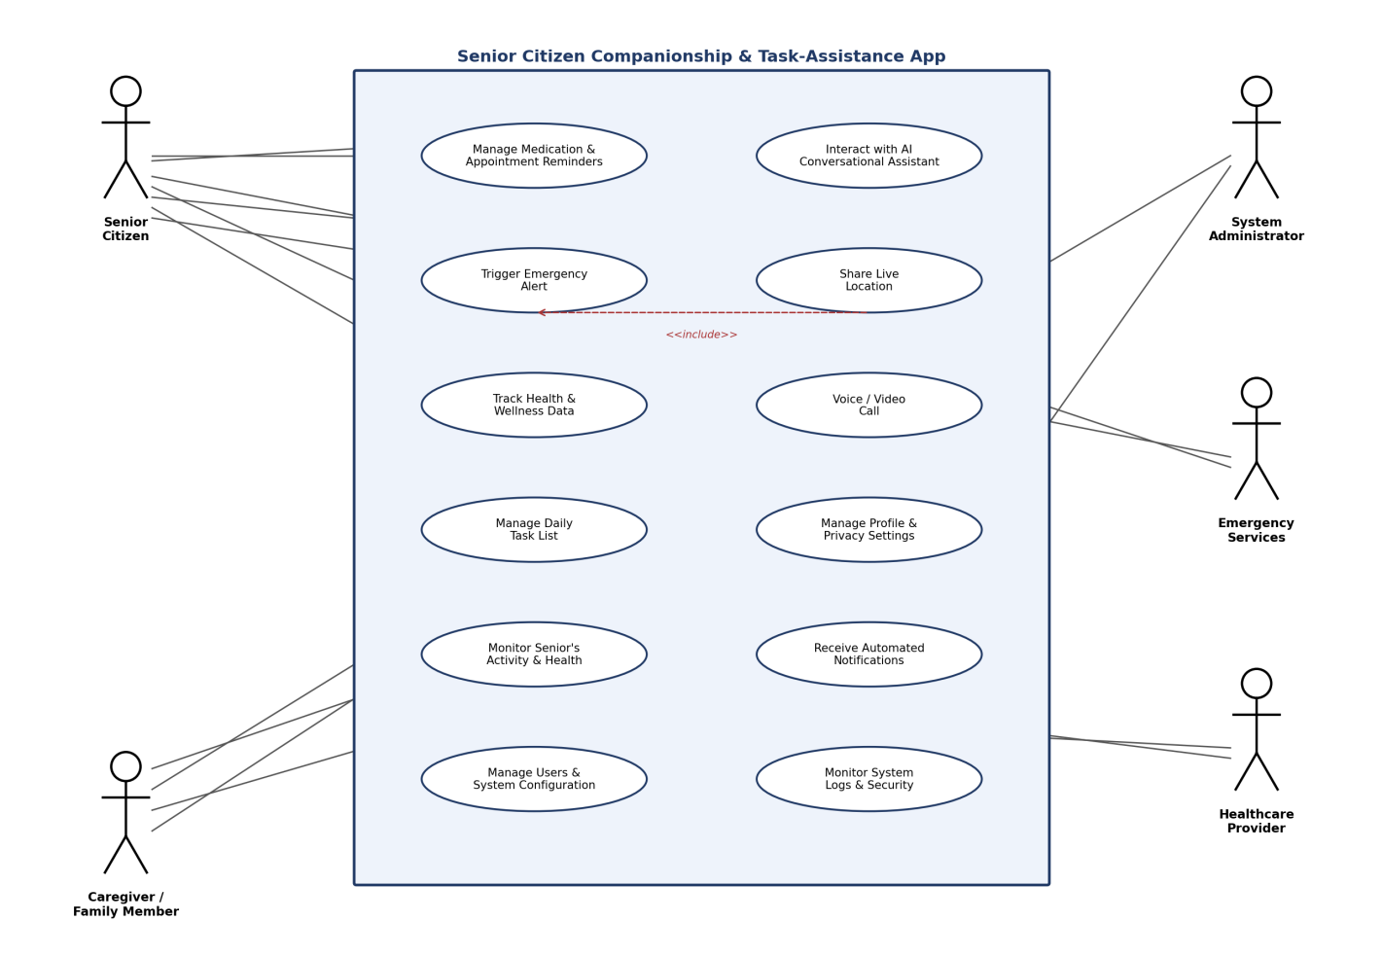

6.3 Use Case Descriptions
Use Case | Primary Actor | Description | Includes/Extends
Manage Medication & Appointment Reminders | Senior Citizen | User (or caregiver) creates, edits, or deletes recurring reminders; system delivers alerts. | —
Interact with AI Conversational Assistant | Senior Citizen | User converses with the AI via voice/text for companionship, check-ins, or simple queries. | Extends: Escalate distress alert
Trigger Emergency Alert | Senior Citizen | User activates SOS; system notifies caregivers/emergency services. | Includes: Share Live Location
Share Live Location | Senior Citizen / System | System captures and transmits current GPS location to caregivers. | Included by: Trigger Emergency Alert
Track Health & Wellness Data | Senior Citizen | User logs or syncs vitals; system stores and visualizes trends. | Extends: Out-of-range alert
Voice / Video Call | Senior Citizen / Caregiver | Either party initiates a real-time call with the linked contact. | —
Manage Daily Task List | Senior Citizen | User views and updates daily routine tasks. | —
Manage Profile & Privacy Settings | Senior Citizen | User manages personal details and data-sharing consent. | —
Monitor Senior's Activity & Health | Caregiver | Caregiver views dashboard summarizing adherence, health, and recent activity. | —
Receive Automated Notifications | Caregiver / Healthcare Provider | Actor receives push/SMS alerts for missed reminders, emergencies, or abnormal readings. | —
Manage Users & System Configuration | System Administrator | Admin creates/edits accounts and configures platform-wide settings. | —
Monitor System Logs & Security | System Administrator | Admin reviews audit logs and security events. | —

7. Data Requirements
Key data entities the system must capture, store, and manage include:
Entity | Key Attributes
User Profile | User ID, name, date of birth, gender, contact number, address, profile photo, role (senior/caregiver/admin)
Emergency Contact | Contact ID, linked user ID, name, relationship, phone number, priority order
Reminder | Reminder ID, type (medication/appointment/task), title, description, schedule/recurrence, status
Medication Log | Log ID, reminder ID, scheduled time, actual time, status (taken/missed/snoozed)
Health Record | Record ID, user ID, metric type, value, unit, timestamp, source (manual/device)
Location Event | Event ID, user ID, latitude, longitude, timestamp, trigger type (manual/fall detection)
Alert / Notification | Alert ID, user ID, type (emergency/reminder/health), timestamp, recipients, status
Conversation Log | Session ID, user ID, timestamp, interaction summary, escalation flag
Consent / Privacy Setting | Setting ID, user ID, data category, shared-with (caregiver IDs), consent status

8. External Interface Requirements

8.1 User Interfaces
- Senior Citizen mobile app: simplified, large-icon, high-contrast interface with voice navigation support.
- Caregiver mobile/web dashboard: activity summaries, alerts, and remote reminder management.
- Administrator web console: user management, configuration, and audit log views.

8.2 Hardware Interfaces
- Smartphone/tablet sensors: GPS, microphone, speaker, camera.
- Optional wearable devices (smartwatch, fall-detection pendant) via Bluetooth Low Energy.

8.3 Software Interfaces
- Push notification services (e.g., Firebase Cloud Messaging / Apple Push Notification service).
- SMS and voice-call gateway APIs for emergency notification fallback.
- Maps/geolocation API for location capture and display.
- Speech-to-text and text-to-speech / conversational AI (NLP) engine.
- Health-platform APIs (Google Fit, Apple HealthKit) for wearable data sync.

8.4 Communication Interfaces
- HTTPS/REST (or GraphQL) APIs between mobile app and backend services.
- WebRTC-based real-time protocol for voice/video calling.

9. System Features
Feature | Priority | Summary
Emergency SOS & Location Sharing | Must-have | Critical safety feature; one-tap alert with automatic location sharing and multi-channel caregiver notification.
Medication & Appointment Reminders | Must-have | Core daily-assistance feature with adherence tracking and caregiver escalation.
AI Conversational Companion | Must-have | Reduces loneliness through proactive check-ins and simple conversational support.
Caregiver Dashboard | Must-have | Central monitoring view for adherence, health trends, and alerts.
Voice & Video Calling | Must-have | Simplified real-time communication between senior and family/caregivers.
Health & Wellness Tracking | Should-have | Manual/device-based vitals logging with trend visualization and abnormal-value alerts.
Daily Task Management | Should-have | General routine and to-do tracking beyond medication.
Wearable Device Integration & Fall Detection | Could-have | Enhances safety through automatic fall detection and passive health data sync.
Admin & Security Console | Must-have | User management, configuration, and audit logging for platform integrity.

10. Assumptions and Constraints

10.1 Assumptions
- Senior citizens or their caregivers have access to a smartphone/tablet with an active internet connection.
- At least one caregiver or family member is available and willing to be linked to the senior's account.
- Users are able to provide informed consent for data collection and sharing, or a caregiver assists with setup.
- Emergency services integration will vary by region and depends on availability of local APIs/partnerships.
- Wearable device integration assumes the user owns or is provided a compatible device.

10.2 Constraints
Type | Constraint
Technical | Must support both Android and iOS with consistent feature parity; dependent on third-party APIs (maps, push notifications, NLP) being available and rate-limited.
Operational | Requires reliable internet/cellular connectivity for real-time alerts; performance degrades in low-connectivity areas for elderly users in rural regions.
Economic | Development and third-party API usage (SMS, calling, AI/NLP, maps) must remain within the allocated project budget.
Legal / Regulatory | Must comply with healthcare data protection laws (e.g., HIPAA/GDPR-equivalent) and obtain explicit user/guardian consent for health and location data.
Time | Must be delivered within the academic/project timeline; a phased rollout (core safety and reminder features first) is required to meet deadlines.
Accessibility | UI must accommodate varying levels of vision, hearing, and digital literacy among elderly users.

11. Requirement Validation and Consistency Check

11.1 Completeness Check
Each stakeholder objective from the problem statement was traced to at least one functional requirement and use case:
Stakeholder Objective | Addressed By
User-friendly mobile app for seniors | FR-1 to FR-3 (accessible registration); NFR — Usability/Accessibility
AI-based companionship | FR-13 to FR-16; Use Case: Interact with AI Conversational Assistant
Daily schedules, reminders, medication alerts | FR-4 to FR-8; Use Case: Manage Medication & Appointment Reminders
Emergency notifications & caregiver communication | FR-17 to FR-21; Use Cases: Trigger Emergency Alert, Share Live Location
Health and wellness monitoring | FR-22 to FR-24; Use Case: Track Health & Wellness Data
Voice/video communication with family | FR-25, FR-26; Use Case: Voice / Video Call
Secure, privacy-preserving data management | NFR — Security, Privacy/Compliance; FR-30 (audit log)
Independent and safe living | Combination of Emergency SOS, Reminders, Health Monitoring, and AI Companion features

11.2 Consistency and Ambiguity Review
- No conflicting requirements were identified; reminder, health, and emergency modules operate on independent data flows that converge only at the notification layer.
- Potential ambiguity: the exact escalation threshold for "repeatedly missed" medication reminders is not numerically defined — recommended to specify this as a configurable caregiver setting (e.g., 2 consecutive misses) in the detailed design phase.
- Potential ambiguity: "signs of distress" detected by the AI assistant needs a precise detection criterion (e.g., keyword/sentiment triggers) to be defined during NLP model design.
- No duplicate/redundant requirements were found across modules.

11.3 Suggested Improvements
- Define explicit configurable thresholds (missed-reminder count, abnormal health-value ranges) as part of caregiver settings rather than hard-coded values.
- Add a formal data-retention and deletion policy to strengthen the Privacy/Compliance non-functional requirement.
- Introduce a lightweight offline mode specification so the SOS feature degrades gracefully (e.g., SMS fallback) when data connectivity is unavailable.
- Add acceptance criteria (measurable, testable conditions) for each functional requirement in the next iteration of this SRS to support test-case design.
- Consider a future-phase requirement for EHR/hospital system integration, currently marked out-of-scope, to expand interoperability.

